Plan
Name(group) title
Concept
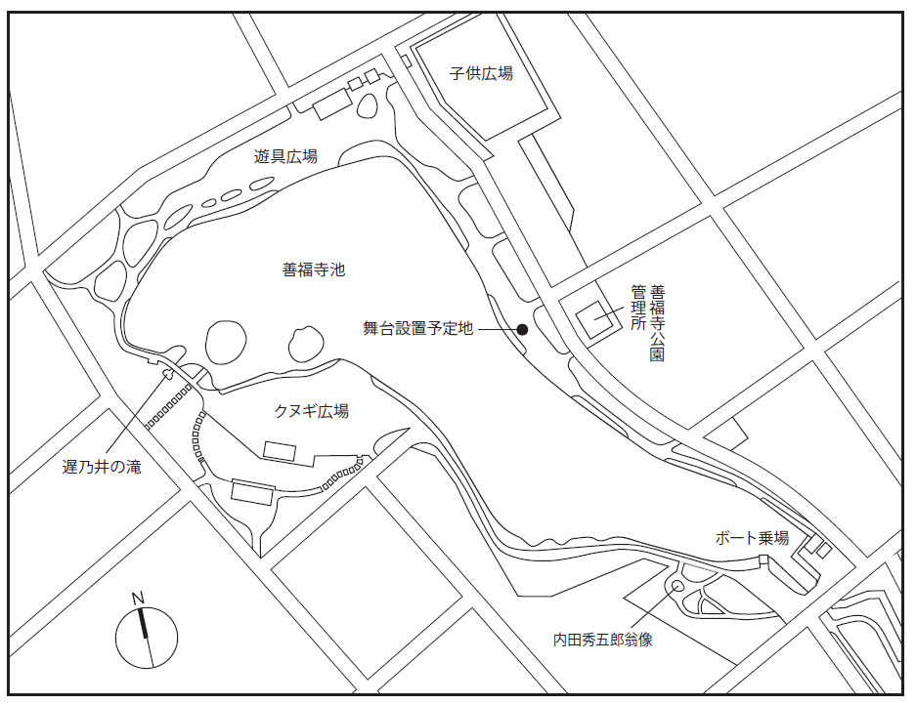
Location (Please mark on the map)
First Choice

Second Chice
弁天島
Visual Image(Idea sketch, photo etc)
Please show the image of your art work.

Assumed dimensions · Material · Weight etc.・

