Plan
Please tick ☑ the appropriate box
Outdoor □ A. Site-specific work in Metropolitan Zenpukuji Park
Outdoor □ B. Performance work in Metropolitan Zenpukuji Park
Town area □ C. Site-specific/Performance work in the Nishi-Ogikubo & Zenpukuji area
Town area □ E. Site-specific/Performance work, workshops,
and other creative proposals that utilize the Momoi Daishi Elementary school

Name(group) Title Medium

(Sculpture, installation, performance, dance, etc.)

Outline of artwork
Please describe the concept or aim of your work in a concise manner, avoiding abstract language.
For site-specific works that include elements of performance, please describe the contents of the performance.
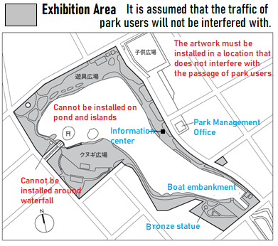
Preferred location of work
For applicants who selected A or B, please fill in the preferred location of your work directly onto the map (please clarify location indicated).
For applicants who selected C, please list proposed sites.

First Choice

Second Choice

弁天島

Image of artwork (Idea sketch, image, photo etc)
For site-specific artwork, please specify the approximate dimensions, materials, weight and estimated time needed to produce the work, etc.

For performance work and proposals for the town area, please specify the preferred date of the performance or event, duration, equipment needed, etc. (please specify if plans are tentative).

Site-specific work |  | Performance work
Category | □ A □C □E | Category | □B □C □E
Approx. size |  | Intended date
Approx. weight |  | Intended time
 |  | Duration | Minutes
Materials |  | Preferred no. of performances | Days/During exhibition:
 |  |  | Times/Per day
Production period (days) |  | Equipment needed
For categories, C and E, preferred length of exhibition |  | Number of participants | Performer
 |  |  | Staff

